**Work-case №2**

**1.**

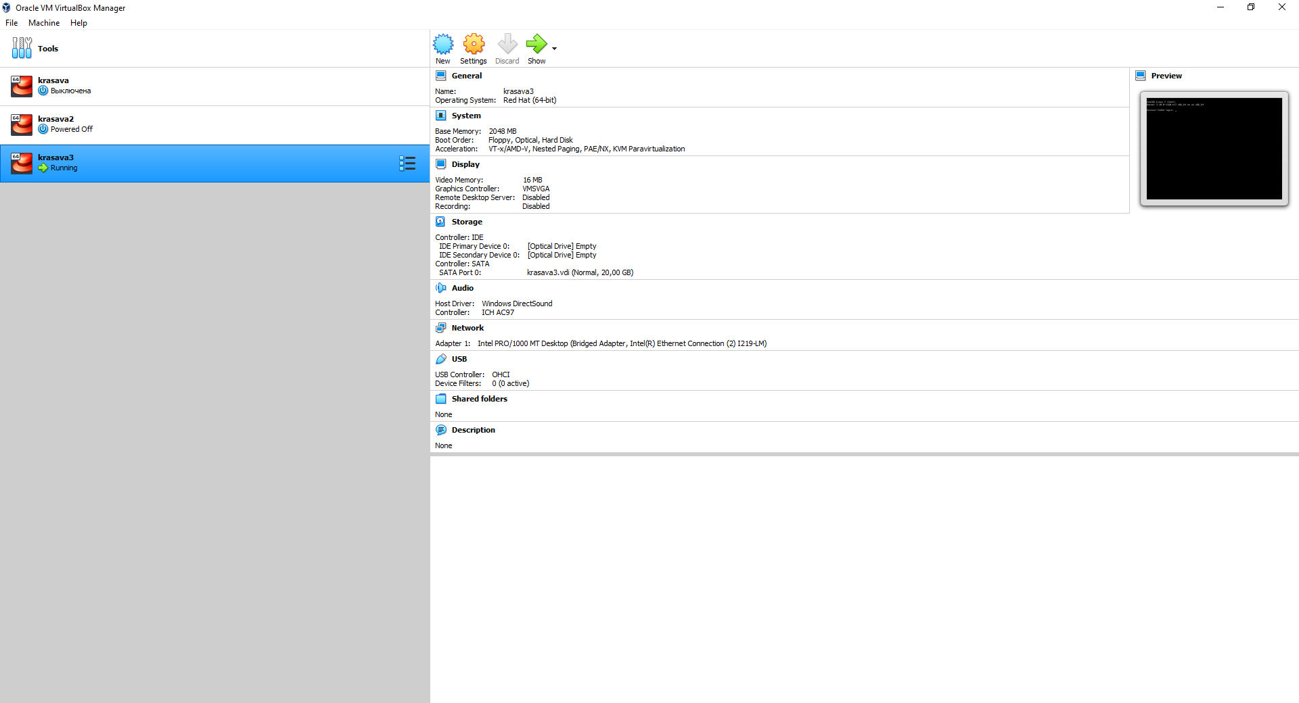

**2.**

1) Creating a new virtual machine in VirtualBox is very simple.

● Firstly you need to open VirtualBox.exe. There will be a button «New» , press it. Then you type in the name of machine you want and select the machine folder. Also it is needed to choose Type of OS you want to install and its version

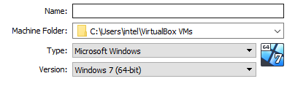

● Then select the amount of RAM to be allocated to the virtual machine. 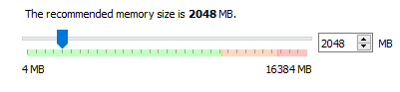

● If you wish you can add a virtual hard disk to the new machine. 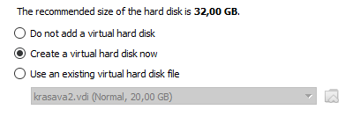

● That is it. Now you can install OS and configure it for yourself.

2) Adding Hardware to a Virtual Machine.

● To add hardware to a selected virtual machine, select VM > Settings, click the Hardware tab, and click Add Hardware. Also you can choose hardware from the existing ones.

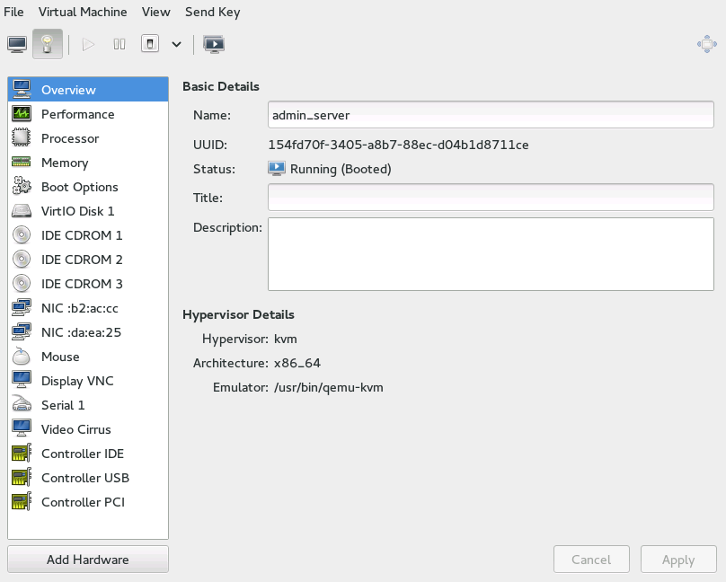

3) To configure network settings click on Virtual Machine and then *Settings.* Click on the *Network* tab. 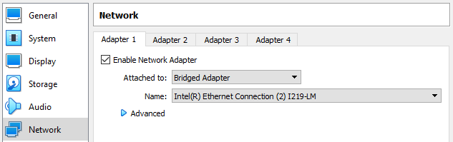

You can choose different connection variants and the interface you want to connect to network with:

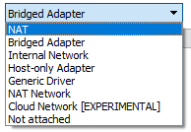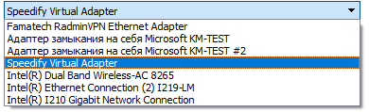

If you are using Wi-Fi connection firstly login to GNOME or whatever GUI you have and there go to settings and connect to the AP you need. But it is necessary to add appropriate interface in Hardware settings of Virtual Machine.

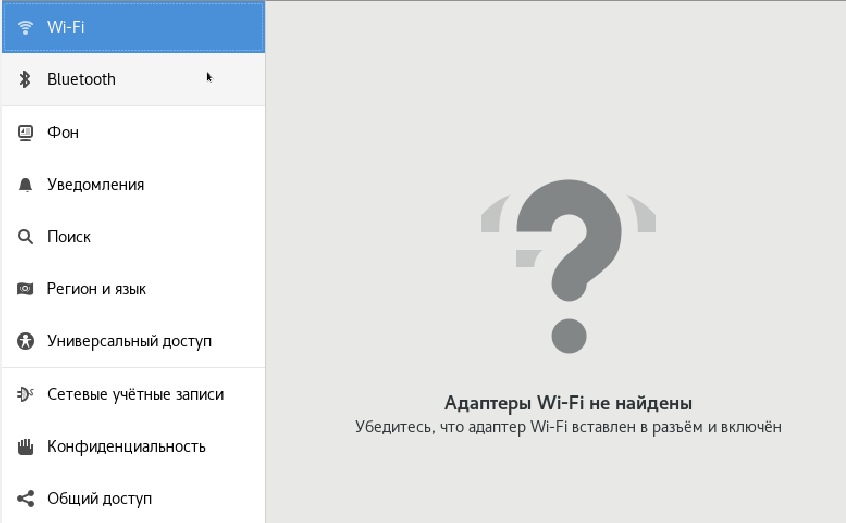

4) It is possible to use external memory. Simply navigate to *Storage* tab in VM’s settings and add whatever drive you want to. Simple and useful. 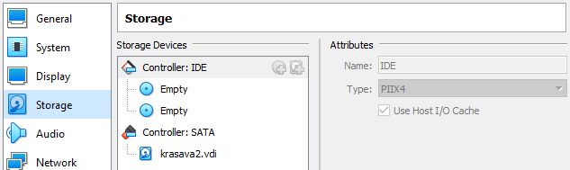

**3.**

1)

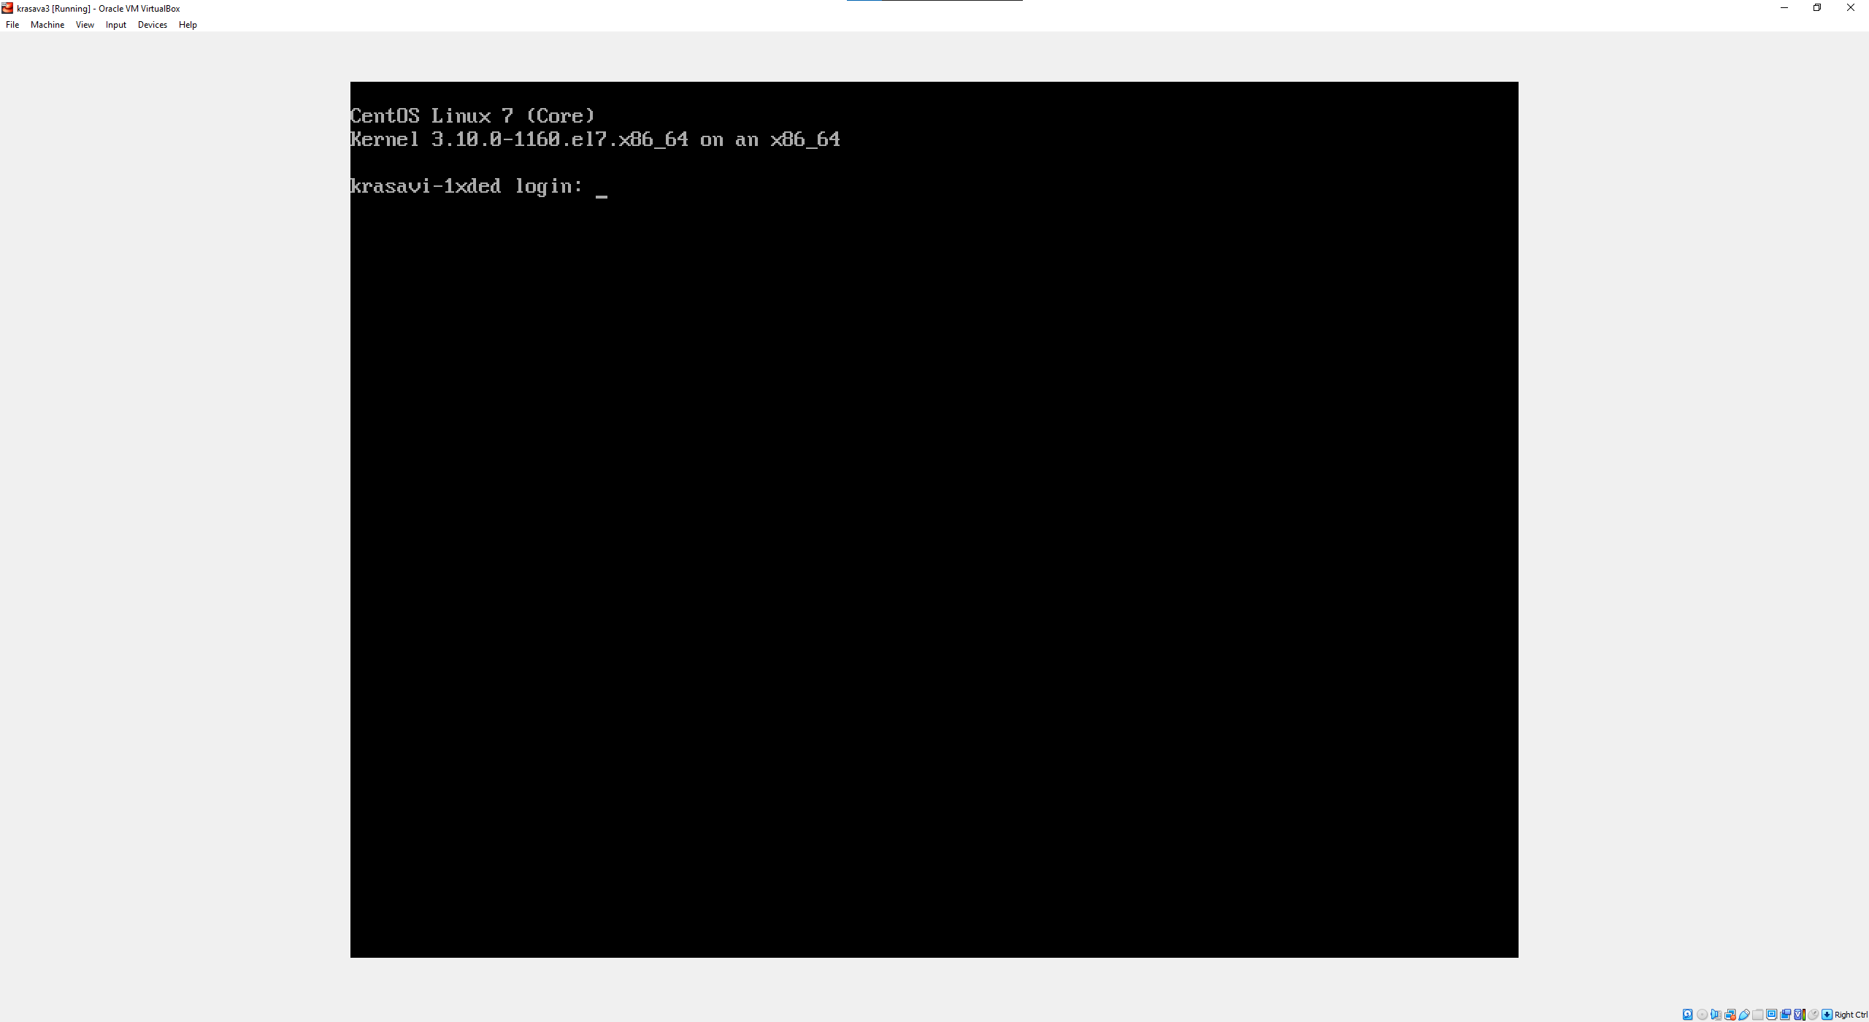

2) 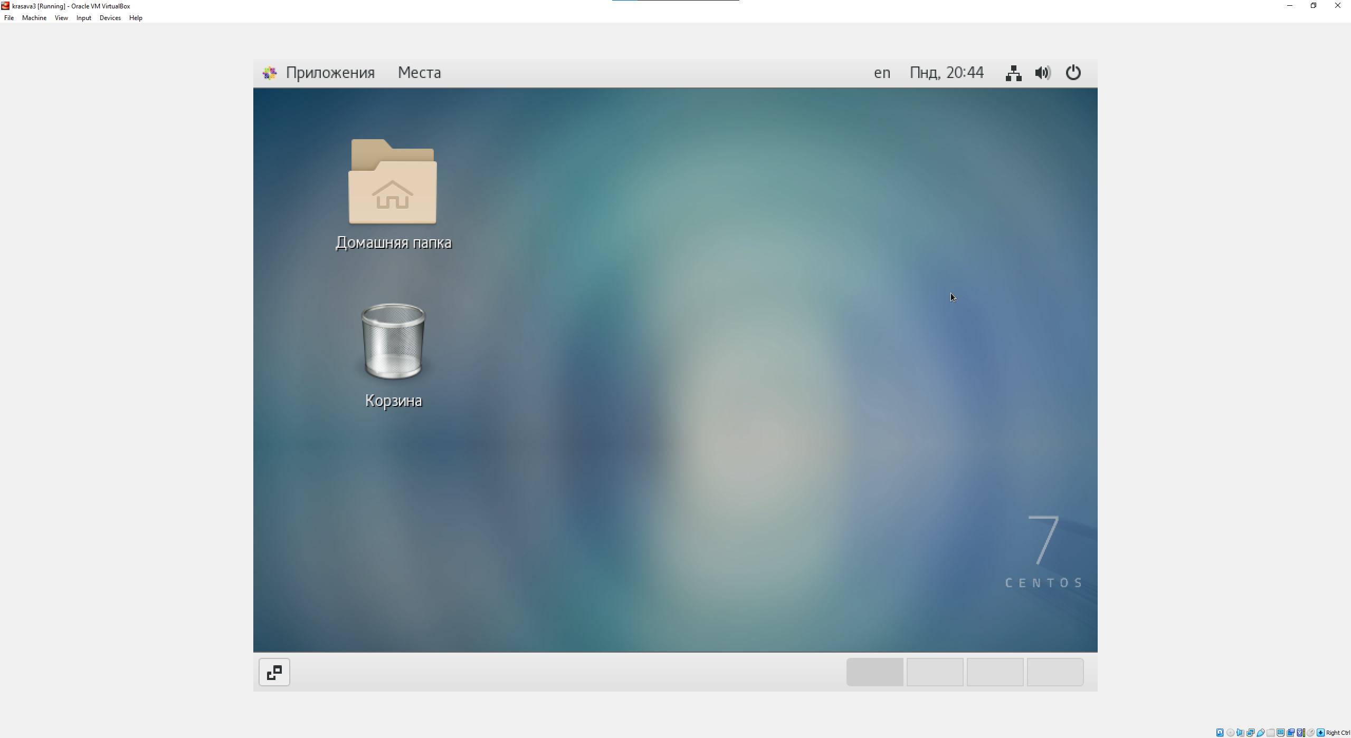

3) Installed KDE Plasma Desktop Workspace

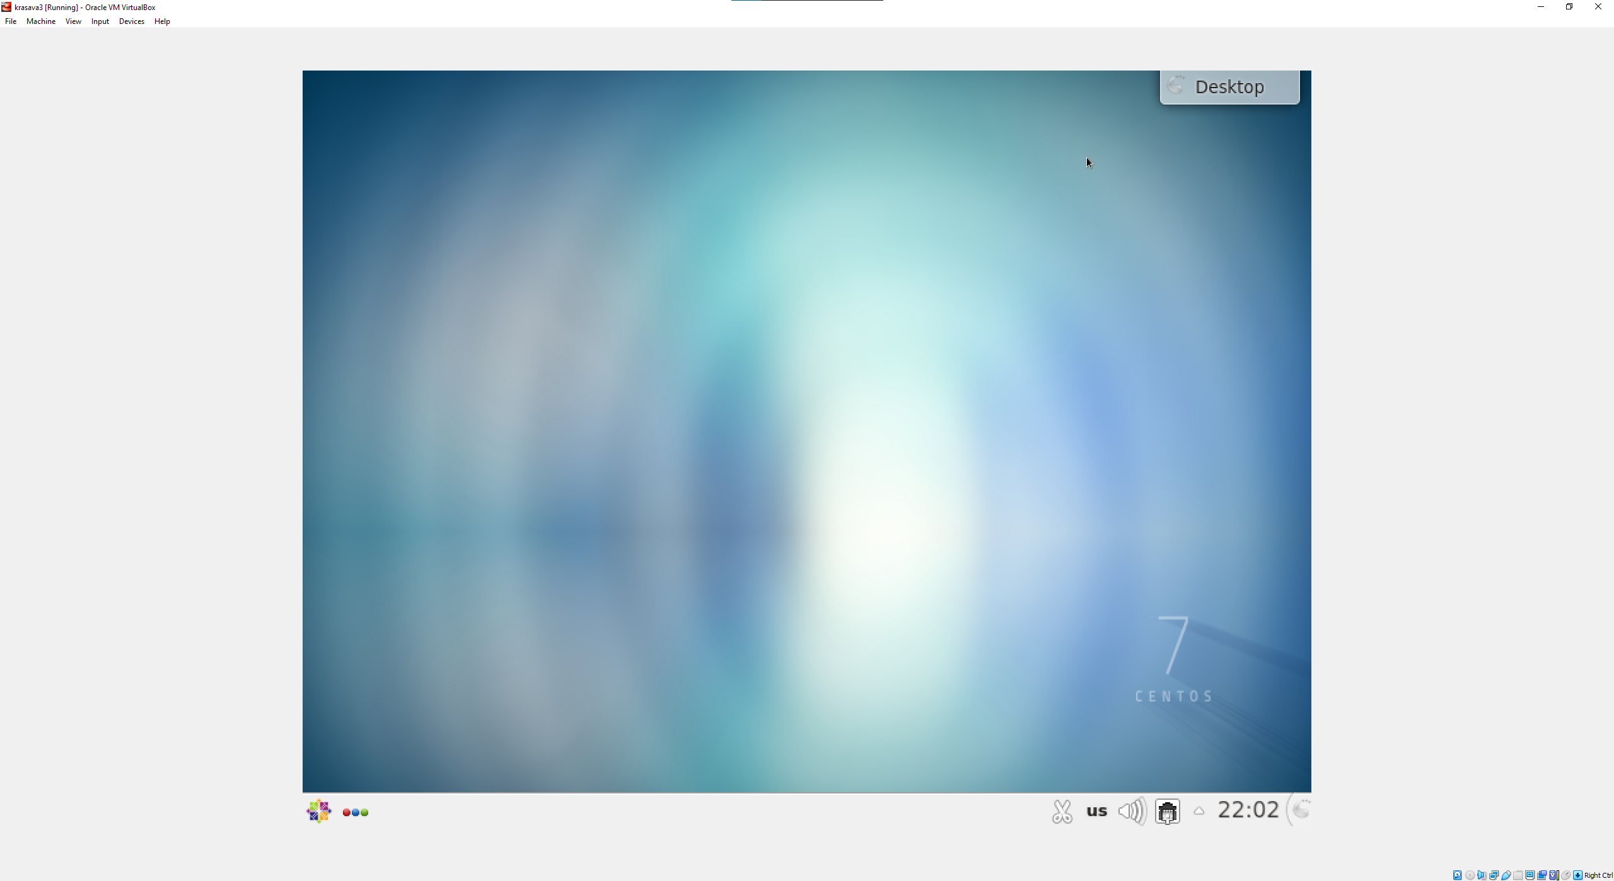

KDE GUI is quite familiar with Windows OS. It has almost the same windows, tabs and abilities. GNOME is a desktop framework that provides cleanliness, openness, and ease of internationalization and localization, whereas KDE is a desktop framework that provides essential tasks and programs to conduct daily chores. KDE is a global freeware group that creates a comprehensive range of

cross-platform apps for Linux. The Plasma desktop aims to provide a traditional desktop layout that’s comfortable for most Windows users. And, KDE is known for its consistent look and feel, even with numerous improvements over the years. GNOME, on the other hand, provides a unique desktop experience. GNOME should suit you well if you are looking for a different and modern user interface design. KDE is the superior choice if you want to tinker and take control of the user experience. As for GNOME, you do not get a lot of out-of-the-box controls. Instead, you will have to rely on GNOME Tweaks or extensions to make some changes. But, yes, you can customize the experience to a good extent. KDE is generally considered faster than most other desktop environments because it is light on resources.

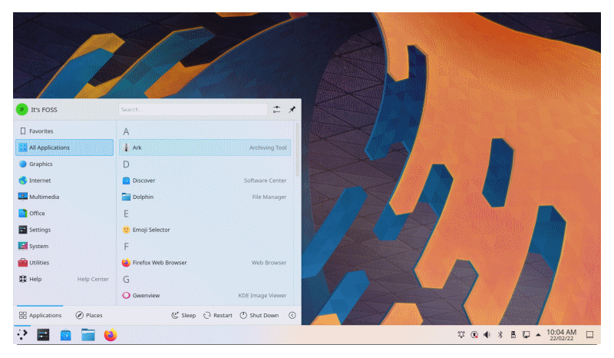Interface comparison:

**KDE**

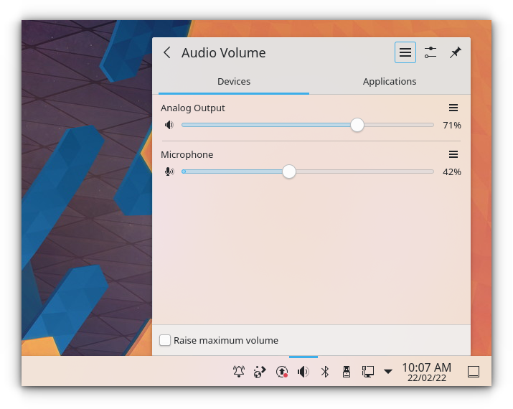

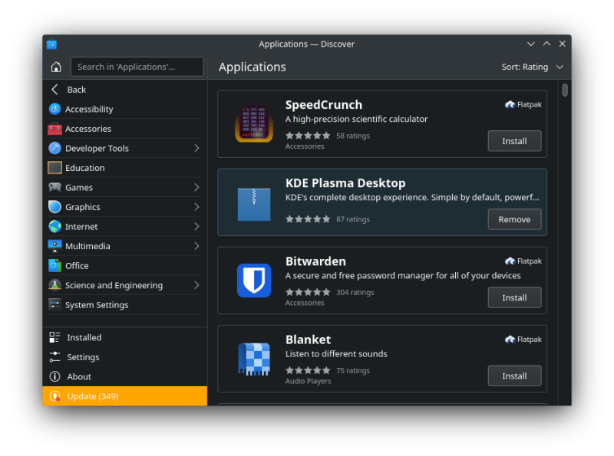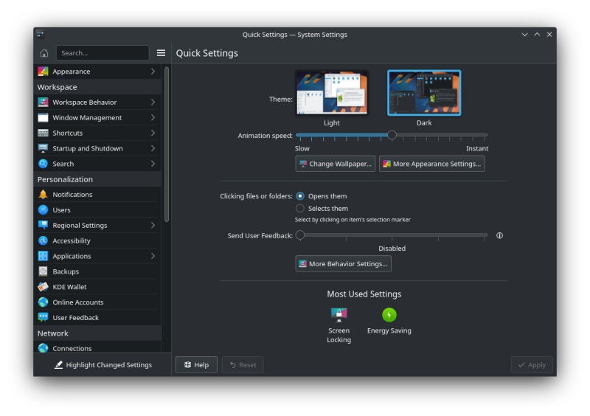

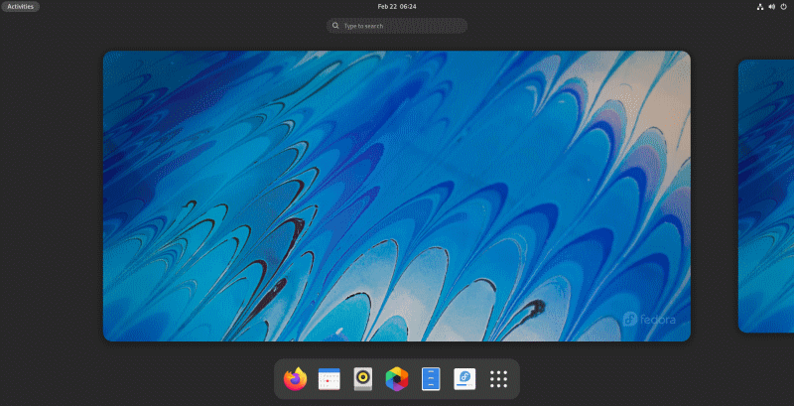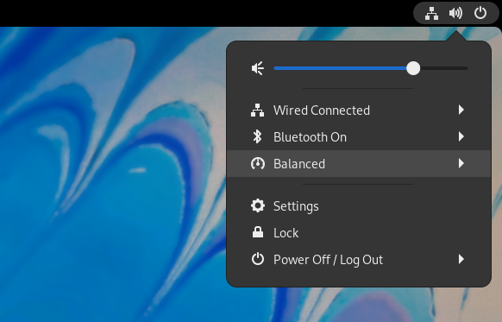**GNOME**

